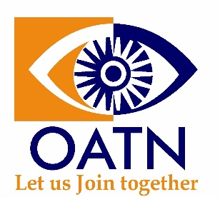

**OPTOMETRIC ASSOCIATION OF TAMIL NANBARGAL**

OPTINT 2024

Cultural Events

College Name:

Faculty Incharge for Cultural:

Contact no.

EVENTS

1. Solo singing (maximum time – 3 minutes)

number of participants:

(if there are no participants kindly mention it as nil)

|  |  |
| --- | --- |
| S.no | Participant name |
| 1. |  |
| 2. |  |
| 3. |  |

1. Group Singing (4 to 6 Participants, Maximum Time – 3 minutes)

number of teams participating:

(if there are no participants kindly mention it as nil)

|  |  |
| --- | --- |
| S.no | Participants names |
| Team 1 |  |
| Team 2 |  |
| Team 3 |  |

1. Solo Dance (maximum time – 5 minutes)

number of participants:

(if there are no participants kindly mention it as nil)

|  |  |
| --- | --- |
| S.no | Participant name |
| 1. |  |
| 2. |  |
| 3. |  |

1. Group Dance (6 to 8 participants, Maximum time – 5 to 7 minutes)

number of teams participating:

(if there are no participants kindly mention it as nil)

|  |  |
| --- | --- |
| S.no | Participants names |
| Team 1 |  |
| Team 2 |  |
| Team 3 |  |

1. Mime (5 to 8 participants, Maximum time – 5 minutes)

number of teams participating:

(if there are no participants kindly mention it as nil)

|  |  |
| --- | --- |
| S.no | Participant’s names |
| Team 1 |  |
| Team 2 |  |
| Team 3 |  |

1. Special Talents (Maximum time – 4 minutes)

number of participants:

(if there are no participants kindly mention it as nil)

|  |  |
| --- | --- |
| S.no | Participant name |
| 1. |  |
| 2. |  |
| 3. |  |

Note:

* ***In case of multiple entries from many colleges each college will be allowed to participate in only two events which will be selected by the college incharge***
* ***Deadline for Culturals Registration – Friday, 09th August, 2024 (12pm)***
* ***Submit your sound tracks on august 31st between 1.45pm to 2.15pm at the venue***
* ***Event coordinator’s contact details***

***Ms. Priyanka – 9677209556 (VIOR)***

***Ms. Yamini – 9843235324 (SRIHER)***